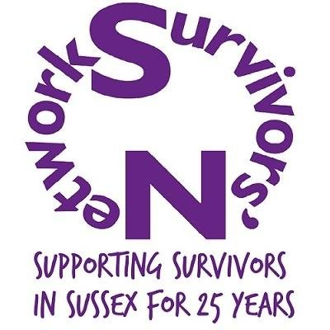

CISVA – Age 0-13 years
Complete and return to: Michele.hyman-wilson@survivorsnetwork.cjsm.net

Date completed: |  | Date received:

Referrer’s Details:
Name | Job Title | Work address | Contact No.

Child’s Details:
Name | D.O.B | M/F | Address
Additional needs:

Attended Paediatric SARC?: Y / N
Forensic Medical Examination completed?: Y / N
Reported to Police? Y / N
If ‘Yes’:
Actions taken:

Officer In Charge:

Parent’s/Carer’s Details:
Name | D.O.B | R/ship to Child | Address (if different from above) | Contact No:
Additional needs:

Child’s Household Composition:
Name | D.O.B | M/F | Relationship to Child
Additional needs:

Alleged perpetrator/s:
Name | D.o.B | M/F | Relationship to Child

Professionals currently involved with child/family
Name | Job Title | Address | Contact No.

Nature of allegations:

Circumstances of disclosure (eg by whom; to whom; when; where)

Actions/Interventions since disclosure (including outcomes)

Additional Needs: (physical, learning disabilities, mental health, literacy, LAC, etc)

Name: Date:

This form is to be completed on behalf of the child.

Equalities monitoring
We collect this information from everyone we work with, to make sure that our services are accessible to everyone in the community. All the information will be kept confidential in line with our data protection policy. However, if you’d rather not share some of this information with us, it’s OK to tick the ‘I’d rather not say’ box, or just leave it blank.
How would you describe your gender? | Female ☐  Male ☐  In another way:_________________ | I’d rather not say  ☐
Are you pregnant? | Yes ☐  No ☐  Not sure ☐ | I’d rather not say  ☐
How would you describe your ethnicity?

White British ☐  White Irish ☐  White Gypsy or Irish Traveller ☐  Any other White background ☐  Asian British ☐  Asian Indian ☐  Asian Pakistani ☐  Asian Bangladeshi ☐  Any other Asian background ☐  Chinese ☐  Arab ☐  Any other ethnic group ☐ | White and Black Caribbean ☐  White and Black African ☐  White and Asian ☐  Any other mixed/ multiple background ☐  Black British ☐  Black African ☐  Black Caribbean ☐  Any other Black background ☐  In another way:  ___________________________ | I’d rather not say  ☐
Do you have a faith/ religion?

No religion ☐  Bahai ☐  Buddhist ☐  Christian ☐  Hindu ☐  Jewish ☐  Jain ☐ | Muslim ☐  Shinto ☐  Sikh ☐  Zoroastrian ☐  Any other religion ☐  Other: | I’d rather not say  ☐
Do you consider yourself to have any kind of disability?  (please tick any that apply) | Physical ☐  Learning ☐  Mental Health ☐  Deaf/ hearing impaired ☐  Blind/ visually impaired ☐  Something else:_________________ | I’d rather not say  ☐

Thanks for completing this form.

