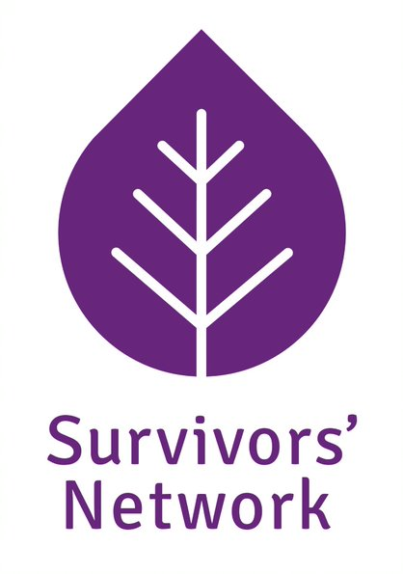

POST DETAILS PACK

Young Person’s Independent Sexual Violence Advisor
(YPISVA)

22.5 hours per week
SALARY: SP 23-25
£27,741 – £29,575

SN is an equal opportunities employer
This post is open to self-identifying female applicants only as being female is deemed to be a genuine occupational requirement under Schedule 9, Paragraph 1 of the Equality Act 2010.
All posts require an enhanced DBS Disclosure

Statement of Vision, Mission and Values

VISION:
Survivors’ Network’s vision is of a world without sexual violence.

MISSION:
Our mission is to support and empower survivors of sexual violence and to work towards ending sexual violence in society.

VALUES:
At Survivors’ Network, we view people accessing our services as survivors, rather than victims. This does not ignore an individual’s experience of victimhood, but rather defines the basis upon which we begin all interactions with service users.

Activist: We will raise awareness of sexual violence, educate, challenge abuse, change behaviour and attitudes.

Connecting: We make connections at many different levels; with and between survivors, supporters, organisations and partnerships.

Survivor Centred: We are committed to survivors being involved at every level of our organisation and the service we provide. Survivors’ Network strives to create an accepting, listening, safe, non-judgemental environment which seeks to validate and understand the survivors’ experiences.

Feminist: We live in a patriarchal society and believe that sexual violence should be challenged from a feminist perspective. Because sexual violence is a gendered crime, we are a women-led organisation committed to offering women-only spaces and services. However, we recognise that sexual violence impacts on people of all genders in unique ways and work to build our services accordingly. We consider a trans inclusive feminism to be key to our values and central to our service. We consider the lack of services and funding for people of all genders to also be a feminist issue and look to build partnerships to address this.

Empowering: We believe that survivors are the expert of their own experience and discovery, and we strive to support them to make their own decisions about their lives. When people are empowered they find creative ways to resolve their own problems and contribute better to wider society.

Committed to Equality: We are committed to improving the accessibility of our services to reach all survivors, especially in relation to their legally protected characteristics (age, disability, ethnicity, gender identity, pregnancy or maternity, marriage/civil partnership status, religion or belief, sex, sexual orientation,). Survivors’ Network is committed to identifying, understanding and breaking down barriers to participation and increasing opportunities and access to all our services and/or seeking funding for new services where need is identified.
Job Description

JOB TITLE: Young Person’s Independent Sexual Violence Advisor (YPISVA)

Based: at the Survivors’ Network office in central Brighton and working across Brighton and East Sussex

REPORTS TO: Children and Young People’s Service Co-ordinator

ANNUAL LEAVE: 5.6 weeks plus bank holidays plus additional days at Christmas

PENSION: 3% workplace contribution

Purpose of Job

To provide a pro-active service, within a multi-agency setting, to young people who have been affected by sexual abuse, especially in relation to the criminal justice process.

To ensure all support is of a consistently high quality and responsive to the needs of service users and the community

To promote Survivors' Network within partnerships

To raise awareness of the issues relating to and the needs of survivors of sexual violence

Specific Duties

Operational Delivery

Manage a caseload of young people from Brighton & Hove and East Sussex who have experienced sexual violence and maintain case files and records, including monitoring information, as required

Assess support needs of young people who have experienced sexual violence and liaise with safeguarding, health, education, counselling and other services as required in order to create a comprehensive support plan

Support young people to understand and access their rights and make informed choices about options open to them where appropriate

Advocate for young people especially within the criminal justice systems, ensuring that their welfare and needs are central to the process

Work within a multi-agency setting to share information and provide individual advocacy for clients and to keep their voice at the heart of the service

Help young people to develop their own support network and access relevant support

Strategic Development

Work with the CYP team to promote and develop the service in accordance with Survivors’ Network policies and ethos

To deliver training, provide consultancy on and raise awareness of the issues related to supporting young survivors of sexual violence

Provide professional input, support and consultation to multi agency hubs and ensure cases are identified and appropriately supported.

Maintain up to date knowledge on issues relevant to survivors of sexual violence and working with young people

Maintain the profile of Survivors’ Network and contribute to the organisation’s marketing and profile

General Duties

Act in accordance with Survivors’ Network’s and other relevant policies and procedures.

Ensure the Survivors’ Network commitment to working within an Empowerment Model is central to the development and delivery of all services.

Attend and participate in regular training, staff meetings, supervision and other meetings as necessary within the Survivors’ Network team

Carry out occasional evening and/or weekend work as required.

Be committed to personal and professional development and undertake relevant training and CPD opportunities.

Carry out your own administrative duties

Undertake any duties consistent with the post as may be reasonably requested by your line manager, the CEO or the Board of Trustees.

No job description can cover every issue which may arise within the post at various times and the post holder is expected to carry out other duties from time to time which are broadly consistent with those in this document.

Essential Criteria | Assessed by
Extensive experience of communicating with young people (aged 17 and under) who have experienced trauma or adverse life experiences in order to engage and support  Knowledge and understanding of the issues relating to sexual violence  Knowledge and understanding of the barriers young people face in accessing services and how to address these  Experience of undertaking collaborative assessments (including risk assessments) and support planning including options related to criminal justice system, education, housing, mental health etc.  Experience of working with safeguarding issues and knowledge of relevant procedures  Experience of working with partner agencies (including statutory and voluntary services) to provide joined up support for clients and to advocate on behalf of the client  Experience of maintaining confidential case files, founded in a working understanding of data protection and confidential working practices.  Considerable experience in software packages eg Office  Car owner with full driving license and willingness to travel across Sussex as required by the post  GENERAL:  Committed to personal development and having the ability to critically assess own performance and engage in reflective practice  Excellent written and oral communication skills  Self motivated and focused on delivering high quality services with an ability to function effectively in high-pressure situations  Commitment to self care and maintaining appropriate professional boundaries  Ability to think creatively and show initiative  Commitment to the vision, mission and values of Survivors' Network  Commitment to anti-discriminatory practice, equal opportunities and an intersectional understanding of feminism. | Application and interview
Desirable Criteria | Assessed by
Qualified ISVA or relevant professional qualification  Experience of supporting young people through the criminal justice processes  Knowledge of child development and/or child psychology  Experience of using an online case management system | Application and interview

